**Lab 8.2**

***Re-write the sort program (and save it as LastFirst_lab82a.cpp ) so that it orders integers from largest to smallest rather than smallest to largest.***

***Take a screen shot of the output. Save it with your comments.***

I just changed the "<" symbol to ">" in the selectionSortArray function, where the if statement is located. So now it reads:

if(array[index] > minValue)

***Take a screen shot of the output.***

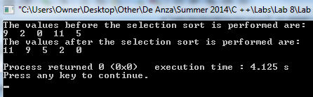

***Modify your program (and save it as LastFirst_lab82b.cpp ) so that it prints the array at each step of the algorithm. Try sorting the array***

***23 0 45 -3 -78 1 -1 9***

***by hand using whichever algorithm you chose. Then have your program do the sort. Does the output match what you did by hand?***

***Take a screen shot of the output. Insert it with your comments.***

Assuming my program still ought to output the values from largest to smallest, I modified the code so that it prints the array at each step of the algorithm (please see my cpp code) using these values:

23,0,45,-3,-78,1,-1,9

Here's the output:

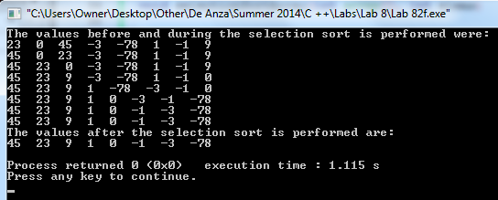

The output is perfect, and it does display what I did by hand.

**Thank you Mr. Ahrens for a wonderful quarter =)**